Calypto’s Windows Latency Guide
Smoother, more responsive gameplay and input

Latency is the time between a cause and an effect. An example of latency is input lag, or the time between moving your mouse and the cursor moving on the screen. A good portion of latency comes from the operating system. In this guide, I list methods to decrease input lag. This guide is mostly oriented towards gamers, but would help for any realtime application on Windows. Google is your friend if you’re not sure about something in this guide (avoid forums and Reddit). These tweaks aren’t listed in any particular order, but they are all important, otherwise I wouldn’t bother listing them. Individually, many of these tweaks probably won’t produce a perceivable difference, but if you do every single tweak you will end up with a significantly more responsive system, even if you usually can’t tell.

You’ll have to change the way you use a PC. In terms of programs, you will need a minimalistic approach. Don’t run anything in the background that you don’t absolutely need. Heavy programs such as your web browser (Spotify and Discord are reskinned Google Chrome) will slow down your system and cause stuttering. Close them before gaming and reopen them when you’re done. This goes for other programs. Windows will allocate CPU time to any service or program that is running in the background and will halt all other programs until the designated program gets its CPU time. This is how multitasking works on operating systems. If you’re curious about scheduling and multitasking, read this, or this.

Measure your latency
Before doing anything in this guide, measure your latency using LatencyMon then compare after doing everything. Go to “Stats” and record your average interrupt to DPC latency, as that is what we want to decrease. You may have to restart the test a few times to get consistently low averages. The lowest possible average is reproducible, so make a mental average. Anything under .4us is good, under .3us is ideal but difficult to achieve, and impossible to achieve on Ryzen due to its architecture and limitations of Windows. When testing latency, every background program should be closed.

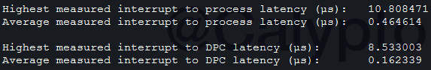
The averages are quite low. The averages are what you are looking to improve. Intel will have lower averages than AMD. Different timers (TSC/HPET/PMT etc.) will give different results.

Measure your polling (smoothness)
The next thing you want to measure is your mouse polling using MouseTester originally written by microe and updated to 1.5.3 by dobragab. Stable mouse polling is extremely difficult to achieve on any multipurpose operating system as it’s not considered a realtime application. For gaming, mouse polling is extremely important and stability is desired. “Stable” polling is very hard to achieve on a system with lots of programs and services running in the background which consequently makes games run not as smoothly, so mouse polling can be used to indirectly measure the smoothness of games. When testing polling, every background program should be closed.

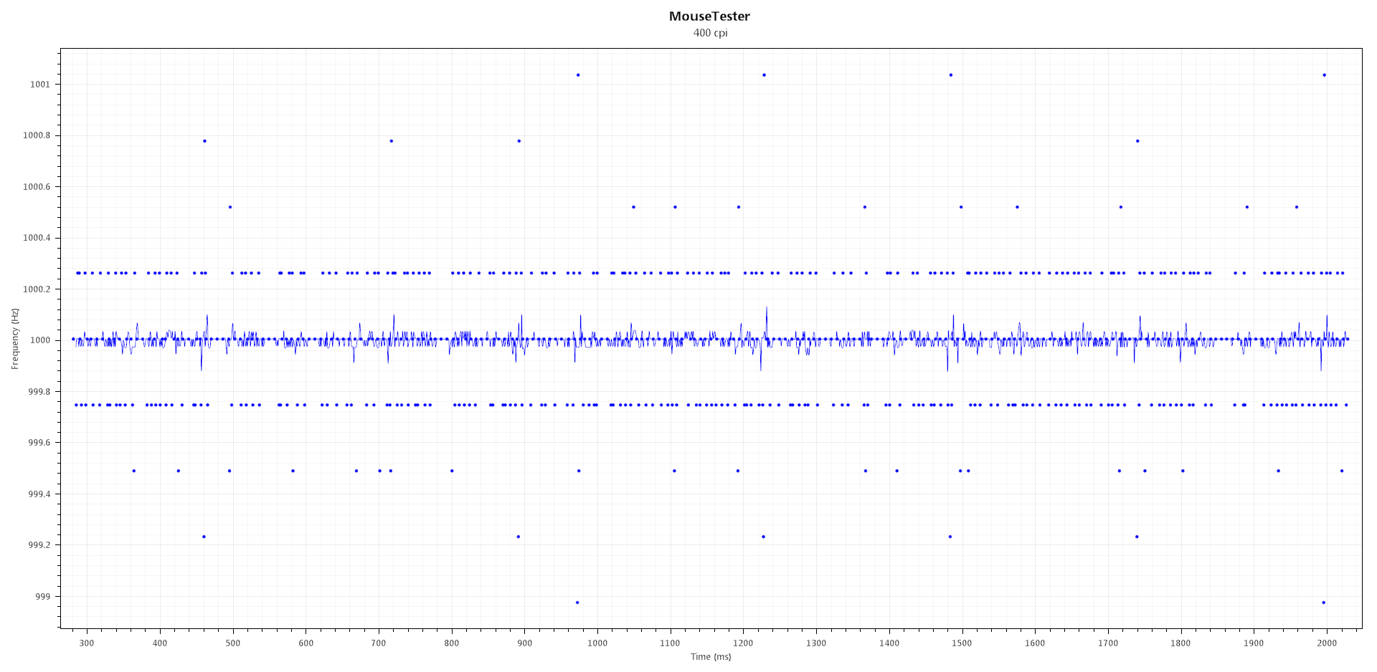

The Tweaks:

Disable Hyper Threading(Intel) / SMT(AMD)
Simply put, this feature doubles the number of registers, but there is still only one execution unit (what does the actual calculation). Since you have two registers, the code will have to wait in the second register until the code from the first register finishes executing, which results in roughly 5-40% higher interrupt to DPC latency. SMT gives a performance benefit for highly-threaded applications such as rendering or compiling, but hinders gaming performance as you get worse responsiveness and FPS. If you don’t know, just turn it off (generally it should always be off on a gaming PC, unless you have a dual core processor, or the game you are playing is highly threaded and you don’t care about mouse response). Disabling HT/SMT will lower the CPU’s energy usage so you can also use a higher frequency at the same voltage.

Don’t use Ryzen CPUs
AMD used a special interconnect architecture in order to make CPUs with lots of cores for a low price. This is great if you want a workstation PC, not a gaming PC. Ryzens consist of two sets of cores in one die and are connected via the Infinity Fabric. The Infinity Fabric is fast, but not fast enough to not have noticeable performance loss in games, as well as high latency due to driver and OS code being executed on both sides of the CPU. Ryzens also have higher memory latency. Expect 1-3ms of extra input lag on a Zen system. If you happened to buy a Ryzen, you can still mitigate the CCX latency, but not the memory latency by doing this:
- Disable a CCX (4+0 in your BIOS, only available on the 8 core SKUs)
- Windows 10 1903 has a scheduler update to group threads to CCXs but is not as low latency as disabling a CCX, another drawback is that you have to use Windows 10 1903, the more recent the Windows version the worse it is for latency due to bloat
- If you absolutely need all 8 cores, set affinity to 0-3 or 4-7 in Task Manager to minimize inter-CCX communication, alternate logical CPUs if necessary (0/2/4/6 or 8/10/12/14 odd or even doesn’t matter [for SMT on])

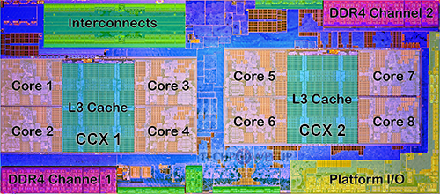
Disabling a CCX will reduce latency since only local cores are available

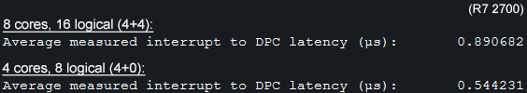
Setting 4+0 in BIOS on Ryzen dramatically reduces interrupt to DPC latency

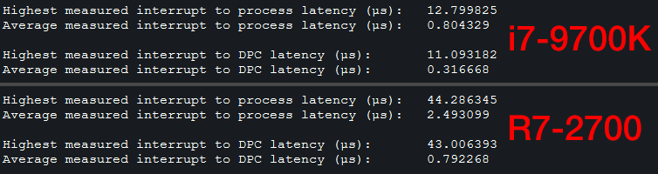
Intel vs. AMD latency

BCDEdit and system timers
Run Command Prompt as admin and paste these italicized commands (right click and paste only the ones you need):
- To undo a command in BCDEdit, do bcdedit /deletevalue X (where X is useplatformclock, x2apicpolicy, etc.)
bcdedit /set disabledynamictick yes (Windows 8+)
- This command forces the kernel timer to constantly poll for interrupts instead of wait for them; dynamic tick was implemented as a power saving feature for laptops but hurts desktop performance
bcdedit /set useplatformtick yes (Windows 8+)
- Forces the clock to be backed by a platform source, no synthetic timers are allowed
- Potentially better performance, lowers timer resolution to .488 instead of .5ms
bcdedit /set tscsyncpolicy [legacy | default | enhanced] (Windows 8+)
- Tells Windows which implementation of TSC to use, try all three and see which you prefer, legacy should be lowest latency but may not result in smoothest FPS
bcdedit /set x2apicpolicy enable
- Enables x2APIC support, should be enabled by default but for safe measure you can force it on

Alternate clock sources
By default, Windows uses the Time Stamp Counter (TSC) which is a timer located directly on the processor. Along with the TSC, Windows uses the either the High Precision Event Timer (HPET) or ACPI Power Management Timer (PMT) for multimedia applications, both of which are located in the platform controller hub (PCH) on the motherboard. Normally the TSC is the default timer; however, you can set either the HPET or PMT to be the default timers in Windows. The HPET and PMT are both highly stable and high frequency clocks that may potentially allow for smoother gameplay and better synchronization throughout the system at the expense of latency. To force these external timers in Windows, paste this command:
bcdedit /set useplatformclock true
- Forces either HPET (10MHz, 14.318MHz, or 24MHz) or the PMT (~3.579MHz) if HPET is disabled in BIOS
- This will result in higher latency and lower FPS in exchange for potentially better smoothness. On Intel it is generally recommended to disable the HPET in BIOS, on AMD it’s not as clear cut
- Your mileage may vary, so be sure to test TSC+HPET / TSC+PMT / HPET only / PMT only. Different games may also like different timers. Different Windows versions (7/8/8.1/10) all have different ways of using the TSC
- If you would like to switch between the HPET or PMT, you would have to disable the HPET in BIOS to let Windows use the PMT
  - Some motherboards have no option to disable HPET, if so, you’re out of luck (typically newer boards such as Z390 don’t have the option)
- You can test your timer using WinTimerTester and compare it here: https://wiki.osdev.org/Timer_Interrupt_Sources
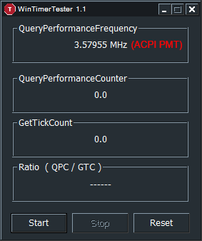

Disable processor idle states
Results in lower latency and more stable mouse polling, also higher max FPS (~1%). Test this variable based on your needs. Make sure you have adequate cooling. Don’t use this for gaming if you have SMT/HT enabled as Windows sleeps the second logical processor of the physical processor for better performance.
- Run CMD as admin:
- powercfg -attributes SUB_PROCESSOR 5d76a2ca-e8c0-402f-a133-2158492d58ad -ATTRIB_HIDE
- Open power management options in Control Panel, set your plan to "Maximum Performance", open the power plan, go to advanced settings, then set “Processor idle disable” to “Disable idle” under processor power options.
- Power saving has no place on a gaming machine
- I’ve listed the commands below which you can paste into .bat files and run from your desktop if you don’t want your CPU running at 100% all the time:

Enable idle: (less responsive, lowers temperature)
powercfg -setacvalueindex scheme_current sub_processor 5d76a2ca-e8c0-402f-a133-2158492d58ad 0
powercfg -setactive scheme_current
Disable idle: (more responsive, raises temperature)
powercfg -setacvalueindex scheme_current sub_processor 5d76a2ca-e8c0-402f-a133-2158492d58ad 1
powercfg -setactive scheme_current

SetTimerResolutionService.exe (by mbk1969)
http://www.mediafire.com/file/d8vt6ehzooah2so/SetTimerResolutionService.zip/file
Download and follow the instructions in the readme. Then, open services.msc (win+r) and set “Set Timer Resolution” service to Automatic.
- This service increases the resolution of the Windows kernel timer, which will significantly lower latency
- Alternatively you can manually run a program in the background whenever you need it in case you can’t install the above

Disable your antivirus
Antivirus causes stuttering. Instead, scan files before running them and do frequent system scans. Don’t visit shady websites, and don’t browse the Web without an ad blocker.

Device Manager
Open Device Manager and disable anything you’re not using. Be careful not to disable something you shouldn’t. Uninstalling a driver via Device Manager will most likely result it in it reinstalling after reboot. In order to completely disable a driver, you must disable it instead of uninstalling. When you disable something in device manager, the driver is unloaded. Drivers interrupt the CPU, halting everything until the driver gets CPU time (some drivers are poorly programmed and can cause the system to halt for over 1ms). What to disable:
Display adapters:
- Intel graphics (if you don’t use it, also should be disabled in the BIOS)
Network adapters:
- All WAN miniports
- Microsoft ISATAP Adapter
System devices: (May or may not cause problems, worked fine on my X470 R7 2700 Windows 7 system)
- Intel Management Engine / AMD PSP (AMD CPUs)
- Remote Desktop Device Redirector Bus
- System speaker
- Terminal Server Mouse/Keyboard drivers (both)
- UMBus Root Bus Enumerator

Now click on View→Devices by connection
- Expand PCI bus, then expand all the PCI Express Root Ports
- Locate PCI Express standard Upstream Switch Port and disable every single one with nothing connected to it (if you have it)
- Locate Standard AHCI 1.0 Serial ATA Controller, disable any channel with nothing connected to it
- Disable High Definition Audio Controller that’s on the same PCIe port as your video card
- Disable any USB controllers or hubs with nothing connected to them
- Disable any PCI Express Root Port with nothing connected to it

- Here is an example of someone’s device manager to give you a better idea: https://i.imgur.com/HNRezkp.png

Disable unnecessary services
http://www.blackviper.com/service-configurations/
Here is my config for Windows 7: https://i.imgur.com/3BV9qnJ.png
I’ve combed through Windows services myself and have something between “tweaked” and “barebones.” However, even with the “barebones” option there are many services that can be disabled based on your needs. I have no issues at all with other programs.
- Most gaming computers will never be connected to a printer, yet the printer service is always enabled wasting CPU cycles, the same goes for other services

Startup
Windows key+r → msconfig → “Startup” tab
Uncheck everything unless you absolutely need it. Launch it manually when you need it.
- Your PC will start up faster, and once started will run fewer unnecessary programs

Disable your page file
https://tunecomp.net/win10-page-file-disable/
- Windows will use your storage (SSD, HDD, etc.) as virtual memory. While this is great if you have low memory, if your game files are put in virtual memory for whatever reason and need to be accessed mid-game, you will have perceivable stutters
- Don’t disable the page file if you typically max out your RAM or you will most likely freeze your PC

Disable DWM (Windows 7 or lower)
This disables desktop composition which is quite irritating if you want better mouse response outside of games; also helps to test settings on the fly.
- Right click on the desktop
- Personalize
- Select “Windows Classic”
- Also be sure to disable the “Themes” service

Disable power saving features
There are numerous CPU-level bugs that can’t quite be fixed with microcode related to power-saving features. To ensure maximum stability, disable any power-saving features in the BIOS. Keep in mind your CPU will be using more energy due to no power saving which means more heat. Disable these:
- Any P states besides P0
- C states
- AMD Cool&Quiet / Intel SpeedStep (manually overclock your processor instead)

Disable Spectre and Meltdown protection (Windows 10)
Microsoft released patches for Spectre and Meltdown for Windows 10. If you are willing to put your computer at risk, you can gain quite a performance increase if you disable these mitigations.
- https://www.grc.com/inspectre.htm

Calypto’s Power Plan:
My personal power plan that I use. It disables core parking and other power saving features. For Windows 7 only. I recommend making your own power plan using PowerSettingsExplorer if you are not on Windows 7.
- Download this and put it on your desktop
- Open CMD as admin and paste this: powercfg /import "%HOMEPATH%\Desktop\CalyptoPowerPlan.pow"
- Select the power plan in the “Power Options” Control Panel window
- If it fails to import you’ll have to manually get the directory the power plan file is placed in

Process scheduling
“Quantum” is the amount of time the Windows process scheduler allocates to a program. Short quantum will improve responsiveness at the expense of more context switching, or switching between tasks, which is computationally expensive. Think of context switching as downtime between work. Long quantum will improve performance of programs at the expense of lower responsiveness. Why would you want long quantum, then? Well, it minimizes context switching and will make the game run smoother, resulting in better consistency when aiming. However, short quantum could potentially decrease input lag which would improve consistency as well.

The table below lists the possible configurations that you can tell the scheduler to use. You may select Short or Long quantum, Fixed or Variable; and if you select Variable, how much boost (no boost, 2x boost, and 3x boost) to give the foreground program (probably a game). The higher the boost, the better the FPS and smoothness will be, but you may experience degraded input response with high boost. Generally, long quantum results in better smoothness but slightly degraded mouse response, whereas the opposite is true for short quantum. If you use variable quantum then the boost will significantly improve smoothness and FPS at the expense of mouse response.

Open regedit and go to:
[HKEY_LOCAL_MACHINE\SYSTEM\ControlSet001\Control\PriorityControl]
- Add together the decimal values you want and enter that as a decimal to the Win32PrioritySeparation key. Example: 32+4+2. (You cannot use the third column unless you use variable quantum. If you are using fixed quantum, ignore the third column.)
- Decimal 40 theoretically would provide the most responsive input at the expense of smoothness and FPS (short, fixed, no boost). Decimal 22 should provide the smoothest gameplay. Dec 37 is a mix between 40 and 38. There is no set answer here, so feel free to try out lots of options. There is no restart required so you can leave regedit open and keep trying different values while having your game open.
- Possible options: decimal 21, 22, 24, 37, 38, 40
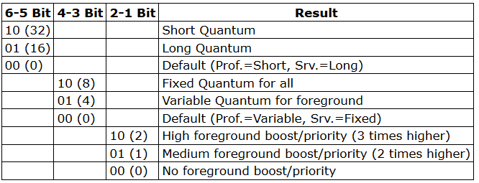
http://recoverymonkey.org/2007/08/17/processor-scheduling-and-quanta-in-windows-and-a-bit-about-unixlinux/

Disable NetBT
NetBT is a legacy driver that's not needed on a gaming machine and has high DPC latency spikes. Download and double click the .reg.
- https://drive.google.com/open?id=1sSSxRgM6CIwnzct4WbDGOu8bM03uRm_u

Disable the Steam browser
Add " -no-browser" without the quotes to your Steam shortcut to prevent steamwebhelper from opening: (you won't be able to use the browser so take it out when necessary)
- Example: https://pbs.twimg.com/media/D6Kp2QrWwAUnLw2.png

Enable MSI mode for drivers
Enabling MSI for a driver that does not support it might break your Windows. Some drivers default to using legacy pin-triggered interrupts, which are now emulated and are slower than using MSI (message-signaled interrupts). If something goes wrong, you can recover with last known settings (f8). On Windows 10 systems the MSI utility should show whether a driver supports MSI or not. Also be sure to prioritize which drivers are more important than others (GPU, USB, their respective PCIe controllers should be high priority)
- To enable MSI mode for drivers, download MSI_util_v2, run as admin, then select your graphics card, audio controllers, PCIe ports. Do not enable it for USB2, SATA controller driver, or anything you’re not sure of. Here is what mine looks like:
- Limit any non-critical devices to 1 or 2. I limited certain root ports and the audio/network controller because a) they still seem to work and b) interrupt the CPU less
- You can check the Device Instance Path (the address listed on the bottom) in Device Manager by right-clicking a device, going to Properties, Details, Device Instance Path
- The PCIe Root Ports for my graphics card and USB controllers are high priority, this is important
- The ISA bridge is high priority too, this is important as well (may be hidden, try enabling using the interrupt affinity tool)
- The Host CPU Bridge(s) should be set to MSI and high priority (may be hidden, try enabling using the interrupt affinity tool)
- Every time you update a driver you have to redo the steps for the updated driver

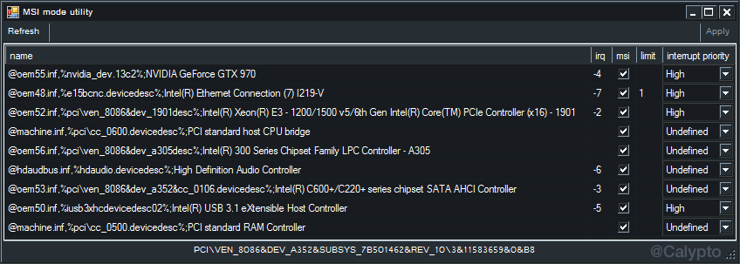
https://forums.guru3d.com/threads/windows-line-based-vs-message-signaled-based-interrupts.378044/ (more info, thanks to mbk1969 for the tool)

Alleviate IRQ sharing
If devices are sharing IRQs (interrupt request lines), they will interfere with each other and increase latency. To prevent IRQ sharing, look at the MSI mode tweak above and do it for each device that supports it. Next, go to Device Manager and view resources by connection, then expand IRQs.

See how the person below has repeating numbers? IRQ 16 is repeated five times, or five devices share one IRQ. This will have a profound effect on latency, and as a result, smoothness. Let’s take a look at how to fix this. The Intel Management Driver should be disabled as it is meant for corporate computers, not home computers. Next, the GTX 680 should be put in MSI mode, as well as the PCI standard PCI-to-PCI bridges. That’s all this user has to do. Ideally, if you can find which USB ports (2.0, 3.0, 3.1) give the best MouseMovementRecorder results, then that’s the port you should use (you can also use MouseTester but it’s a bit overkill as the difference should be quite large). You may have success with disabling the other USB ports and using only one controller as the system has fewer USB controllers running, resulting in better performance. Disable any unused PCI bridges or other unused devices.

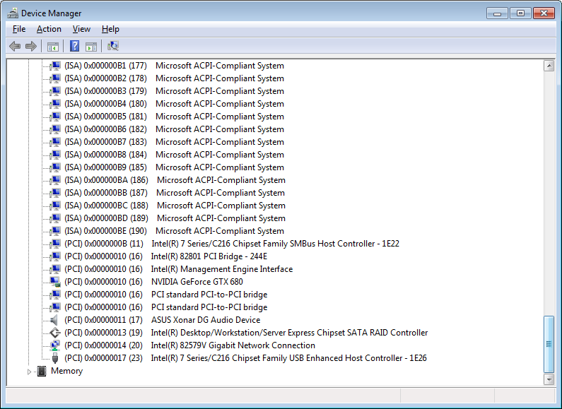

How to properly install NVIDIA drivers
The Nvidia driver executable installs a lot of bloat. Use NVSlimmer to select what you need (enable NvContainer [Nvidia control panel]). Click apply before installing.
https://forums.guru3d.com/threads/nvidia-driver-slimming-utility.423072/

The 419.35 driver has relatively minimal DPC latency spikes compared to other Nvidia drivers. Use NVSlimmer to remove bloat. You can download the 419.35 driver here by scrolling down the list after searching: https://www.geforce.com/drivers

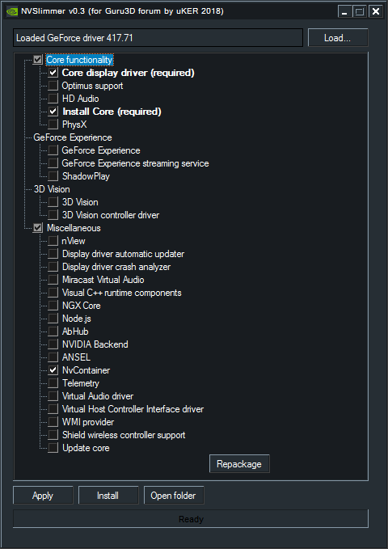

Nvidia 3D settings (low latency)
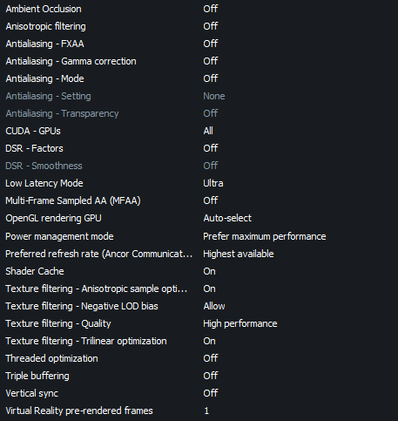

KBoost (Nvidia only)
This tweak forces the GPU to always run at max clock speed. This prevents the GPU from constantly switching back and forth between different clocks which can impact smoothness and performance. Ensure you have adequate load temperatures (<80°C) or you will shorten the lifespan of your card.
- Download MSI Afterburner
- Download and add this skin to C:\Program Files (x86)\MSI Afterburner\Skins (courtesy of user BerserkForces)
- Open the settings and select the “User Interface” tab, then select “Default EVGA PrecisionX 16 Skin”
- Click OK and press “KBOOST” on the right side of the window, then restart your PC

Interrupt affinity
Using Microsoft’s Interrupt-Affinity Policy Tool (backup link), one can set affinity for a driver’s interrupts. Don’t go overboard. You may actually make the system perform worse if you randomly start setting affinities or set too many devices onto a single core.
- Do not change the NVME driver or SATA driver. You will brick your Windows. On Windows 7 you can change the SATA driver, but I’m not sure about NVME.
- Default install dir: C:\Program Files (x86)\Microsoft Corporation\Interrupt Affinity Policy Tool (use the x64 executable)
- Run as admin
- Select a driver and “Set Mask” (this is for IrqPolicySpecifiedProcessors)
  - Select the cores you want the driver to be exclusively executed on
  - If you have HT or SMT, select every other CPU to ensure one core doesn’t get two interrupts at once, there is more nuance to this but generally you don’t want to share execution units
  - If you have a Ryzen CPU, try to keep the drivers pinned to one CCX only (CPUs 0-3 and 4-7 on an eight-core, 0-2 and 3-5 on a six core)
  - Press the “Advanced…” button for other choices if you wish
  - Do not restart any drivers for storage devices or PCIe controllers with storage devices attached, restart your PC instead to prevent risk of data loss
- Open Device Manager and click View→Devices by connection then expand all devices, you will need this to see which devices are under certain PCIe controllers

- These devices are fine to set, as they are most responsible for input/performance:
  - GPU; works best on a single core
    - Set the PCIe controller that the GPU is connected to onto the same core
    - Setting the graphics card onto a single core gives the best performance, however setting it to a busy core will result in worse performance. You will have to find out which core performs best by benchmarking, such as using menu FPS or something very consistent with high FPS (300+) that you can reproduce easily
    - Keep a mental list of cores that are the most performant
  - USB controllers and USB hubs (also works best on a single core, test polling using MouseMovementRecorder)
  - PCIe Controllers (you should set the PCIe controller onto the same cores that you set its devices as, i.e. if you set the GPU to core 0, you should set the PCIe controller as core 0 as well)
  - PCI Standard ISA Bridge / LPC Controller

- Based on my testing, the above settings result in better FPS/responsiveness/smoothness (yes, all three)
- This tool can also show hidden devices in MSI util if you change the setting at least once using this program
- Every time you update the Nvidia driver you may have to reset the affinity

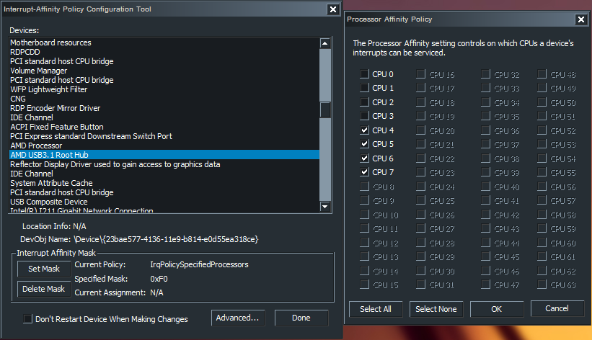

- To check the device ID, open Device Manager, click View and select “Devices by connection,” right click on a device, Properties, Details, Physical Device Object Name
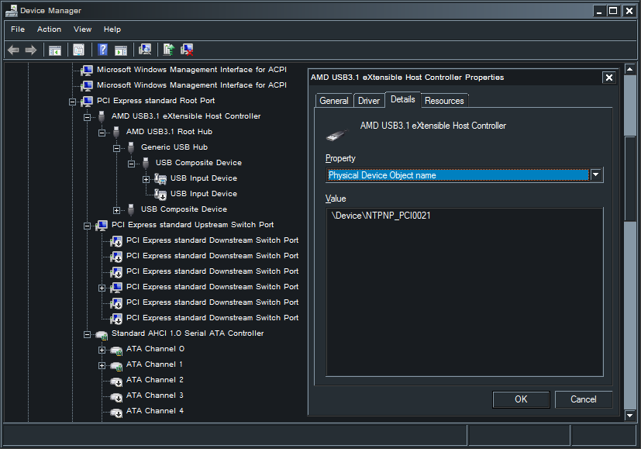

Process Lasso
While this part isn’t necessary, I find this software helpful. If you have SMT/HT enabled, this software is very useful to set core affinities to every other logical processor automatically for better performance in games.
- Download and install: https://bitsum.com/get-lasso-pro/
- Press the Options menu, go to General Settings, Reconfigure the way Process Lasso starts. For the first box select “Do not start at login”, the second box select “Start at login for ALL users,” press Next, “Manage ALL processes Process Lasso has access to”, click finish. This will ensure only ProcessGovernor.exe (the service) runs at login, which will set the priorities of processes automatically.
- Press the Options menu, go to General Settings, Refresh interval (governor), select 10s. This will minimize CPU usage. The “Other” option doesn’t seem to work.
- We want to change the priorities of all programs to lowest priority. Highlight all programs (ctrl+a), right click, Priority class always on Idle.
- Don’t use ProBalance, IdleSaver, or SmartTrim since you already set the priorities of everything to low priority; these features hurt more than help in our use case.
- Under Options, Configure foreground boost, enable both settings.
- Feel free to explore all the other options. You don’t want the user interface (ProcessLasso.exe) running all the time, only ProcessGovernor.exe.
- Don’t use the Bitsum Highest Performance Power plan.
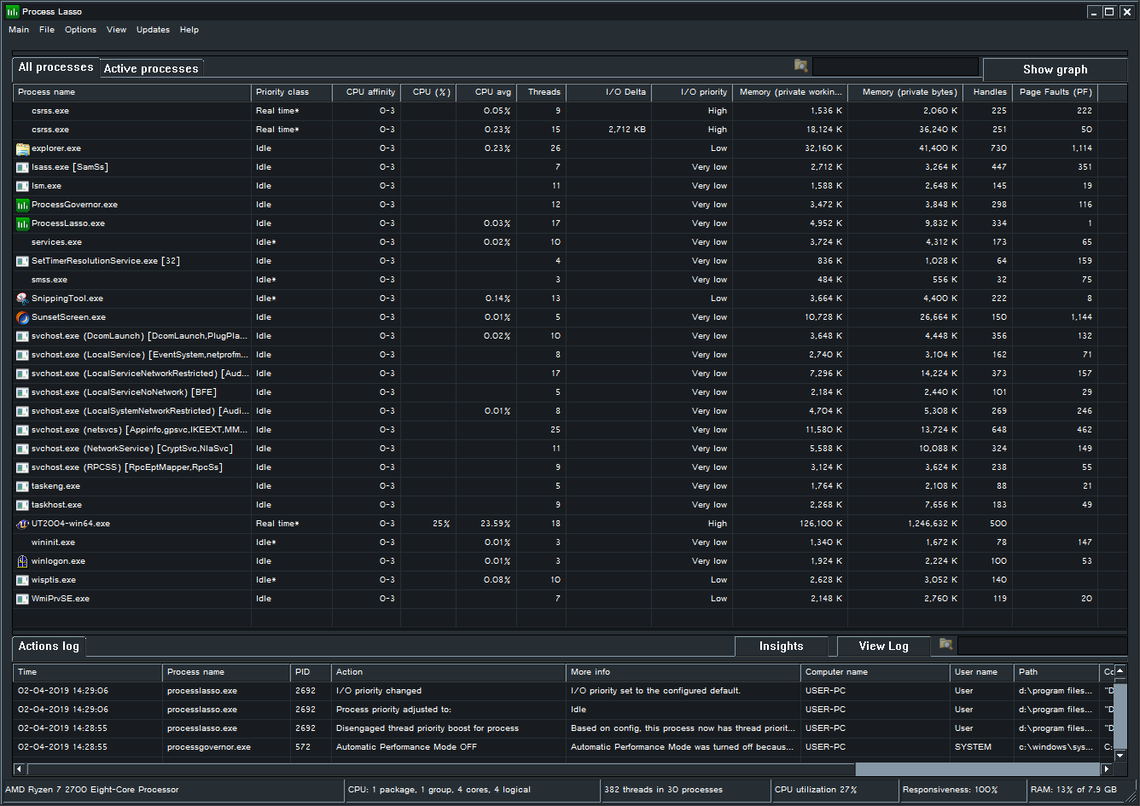
Click for larger image

Miscellaneous links
r0ach’s BIOS optimization guide
https://www.overclock.net/forum/6-intel-motherboards/1433882-gaming-mouse-response-bios-optimization-guide-modern-pc-hardware.html

Optimizing Computer Applications for Latency: Part 1: Configuring the Hardware
https://software.intel.com/en-us/articles/optimizing-computer-applications-for-latency-part-1-configuring-the-hardware

Fujitsu Primergy Server BIOS Settings for Performance, Low-Latency and Energy Efficiency
https://sp.ts.fujitsu.com/dmsp/Publications/public/wp-bios-settings-primergy-ww-en.pdf

Better HyperThreading/SMT explanation
www.cs.virginia.edu/~mc2zk/cs451/vol6iss1_art01.pdf

Perfect Mouse Input Discord
https://discord.gg/PfsdHaP

Follow me on Twitter
https://twitter.com/CaIypto

Please consider donating if you found this guide helpful.
https://www.paypal.com/cgi-bin/webscr?cmd=_s-xclick&hosted_button_id=UQJE6DZ9RX3KQ&source=url


The fruit of my labor. One of the hardest scenarios in Kovaak’s Aim Trainer (now outdated but still a decent score).

